29 Jan 20, Goss

How do you connect to the SQL db on the website through SSMS?

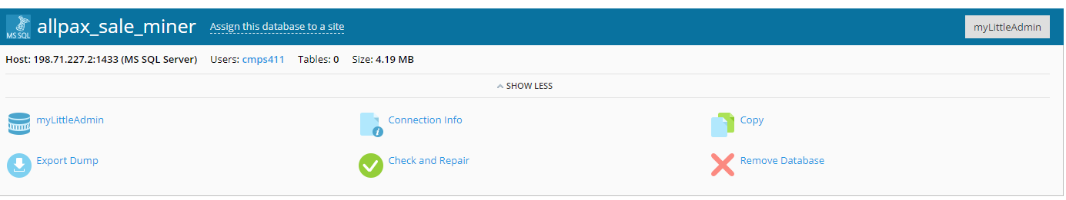

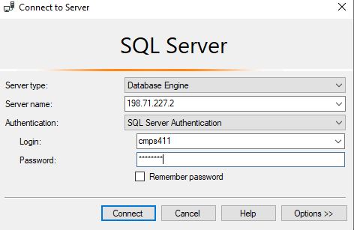

cmps411, Cmps_411

